Topic: Structures | Year group | Term
Design, make and evaluate a free standing picture frame for your family to display in their house. | Year 3 | 6 sessions
Background knowledge
- Freestanding photograph frames stand up on their own, without support or attachments.
- Printed photographs usually go inside.
- Different types of frames display photographs in different ways – ‘windows’ can be different shapes, although these are most commonly rectangular.
- Most commonly, people have photographs of loved ones in their frames and have them displayed in their house.
What should I already know?
- Experience of using different joining, cutting and finishing techniques with paper and card.
- A basic understanding of 2-D and 3-D shapes in mathematics and the physical properties and everyday uses of materials in science.

National Curriculum Objectives
Designing
- Generate realistic ideas and design criteria collaboratively through discussion, focusing on the needs of the user and purpose of the product.
- Develop ideas through the analysis of existing products and use annotated sketches and prototypes to model and communicate ideas.

Making
- Order the main stages of making.
- Select and use appropriate tools to measure, mark out, cut, score, shape and assemble with some accuracy.
- Explain their choice of materials according to functional properties and aesthetic qualities.
- Use finishing techniques suitable for the product they are creating.

Evaluating
- Investigate and evaluate a range of existing shell structures including the materials, components and techniques that have been used.
- Test and evaluate their own products against design criteria and the intended user and purpose.

Technical knowledge and understanding
- Develop and use knowledge of how to construct strong, stiff shell structures.
- Develop and use knowledge of nets of cubes and cuboids and, where appropriate, more complex 3D shapes.
- Know and use technical vocabulary relevant to the project.

Key Skills | The Journey
As a year 3 designer KPI  - I can research existing products to help inspire my design.  - I can design a product using ideas from my research, thinking about who the product is for. (design criteria)  - I can draw an annotated sketch of my design and follow a simple step by step plan.  - I know how to work safely with new tools and materials.  - I can build a structure using wood  - I can use tools with increasing accuracy to cut, shape, join and finish.  - I can explain why I’ve chosen certain tools and materials to serve a purpose  - I can prove that my design meets the criteria | - WALT: Investigate picture frames.  Look at the different shapes and designs used to create picture frames, discuss the materials used and why. Which are the best designs and why? What makes them appealing?  - WALT: Design a picture frame  Set the design criteria-to design a functional and appealing picture frame for ……(parent/guardian?). Think about what this means for our designs. Create an annotated sketch, noting materials chosen and why  - WALT: Make a prototype  Model how to make a picture frame using card, thinking about the shapes needed (basic angle work?). Children have a go at making a card frame so they know the steps needed.  - WALT: Plan how I will make my product  Model the steps needed to make the frame to the children, (cutting, sanding, joining), they then write a simple flow chart or plan for their own frames to follow in the following lesson.  - WALT: Make my picture frame  - WALT: Evaluate my picture frame how does it meet the design criteria

Outcomes
An overview of what children will know / can do

Working towards: I can make simple picture frame from wood with support.
Expected: I can follow steps to make a picture frame safely and carefully from wood.
Exceeding: I can make a well finished picture frame, thinking about the audience in my design.

Key Vocabulary | Timeline / Diagrams
Frame- a rigid structure that surrounds something  Purpose- Function of the product  Audience- the group of people the product is aimed at.  Structure- a building or object constructed of different parts.  Angle  Prototype- a model version of your finished product to check it will work.  Annotated sketch- a drawing of your design with added notes about the design or materials  Flow chart- A set of instructions that shows the steps as boxes of various kinds, and their order by connecting the boxes with arrows.  Saw- a sharp hand tool for cutting wood  Vice- a piece of equipment used to clamp and secure a material before working with | 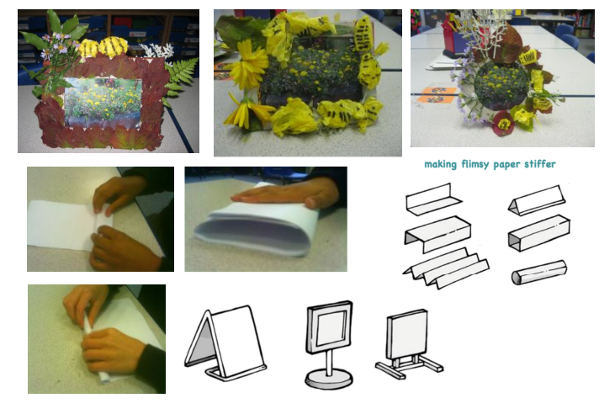

Resources
Card squared paper coloured paper adhesive tap e masking tape, PVA glue, glue spreaders, acetate sheet, pencils, felt-tip pens, rulers, right/left handed scissors

Key people / places
One of the earliest physical frames dates back to AD 50-70; the wooden frame and the portrait within was found in an Egyptian tomb and was almost perfectly preserved. The twelfth and thirteenth centuries brought about the hand-carved, wooden frames that we recognize today.
Assessment questions / outcomes
Which picture frame designs did you think are the most successful? Why?
Which materials will you use to make your frame? Why?
How will your design match the brief?
How will you join your materials together?
Was your design successful? Why/why not?
How would you improve it next time?

