Topic: Textiles | Year group | Term
Design, make and evaluate a christmas decoration to sell at the school fair | Year 3 | 4 sessions

Background knowledge
- It will be the first time the children will be shown how to, and had a go at basic sewing to join fabrics together.
- They will use either running stitch or over stitch and experiment with a range of fabrics.

What should I already know?
Materials can be joined in different ways. Fabrics have different strengths and weaknesses, and can be chosen to suit different purposes. We can use templates to help us cut accurate shapes from a piece of material, and we know how to use scissors safely.

National Curriculum objectives
Designing
- Generate realistic ideas and design criteria collaboratively through discussion, focusing on the needs of the user and purpose of the product.
- Develop ideas through the analysis of existing products and use annotated sketches and prototypes to model and communicate ideas.

Making
- Order the main stages of making.
- Select and use appropriate tools to measure, mark out, cut, score, shape and assemble with some accuracy.
- Explain their choice of materials according to functional properties and aesthetic qualities.
- Use finishing techniques suitable for the product they are creating.

Evaluating
- Investigate and evaluate a range of existing shell structures including the materials, components and techniques that have been used.
- Test and evaluate their own products against design criteria and the intended user and purpose.

Technical knowledge and understanding
- Develop and use knowledge of how to construct strong, stiff shell structures.
- Develop and use knowledge of nets of cubes and cuboids and, where appropriate, more complex 3D shapes.
Know and use technical vocabulary relevant to the project.

Key Skills | The Journey
As a Year 3 designer-  • I can investigate and evaluate existing products to help inspire my design.  • I can design an appealing product for a set purpose and audience.  • I can experiment with different types of basic stitching to help me plan my design.  • I can make a plan using a paper mock up.  • I can make a product from textiles, using basic stitching to join them together.  • I can cut and shape materials confidently on my own, using templates or pattern pieces.  • I can make informed choices about the materials and tools I use.  • I can prove that my design meets the criteria | 1.Walt: Investigate Christmas decorations  Look at the different designs, have a go at basic stitching techniques. Set the design brief with the class: Purpose and audience.  2. Walt: Design a Christmas decoration  Children make a paper model of their Christmas decoration and draw an annotated sketch of the finished design.  3. Walt: Make a Christmas decoration  Model how to use a template again, and the basic stitching techniques  4. Walt: Evaluate the finished product  Complete making the product if necessary and finish neatly. Evaluate and prove how the product meets the design criteria.

Outcomes
An overview of what children will know / can do

Working towards: With support I can use basic stitches to join fabrics together.
Expected: I can use basic stitching to make an effective Christmas decoration.
Exceeding: I can think about the audience to make an appealing and make a effective Christmas decoration.

Key Vocabulary | Timeline / Diagrams
Running stitch- The stitch is worked by passing the needle in and out of the fabric. The needle is always pushed through both layers of cloth starting on the side it is on and ending on the other side. A running stitch runs through the fabric.  Over stitch- a stitch made with a sewing machine, for binding or finishing a raw edge or hem. This stitch goes over the edge of the fabric  Embellishments- Things you add on to your finished product to decorate/add value to the design eg. Buttons, beads, tassels etc. | 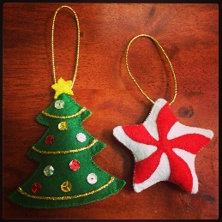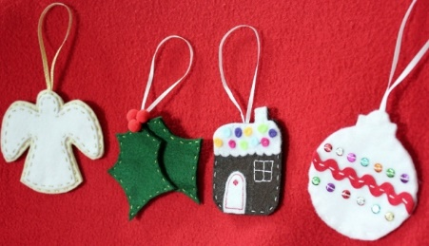  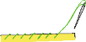  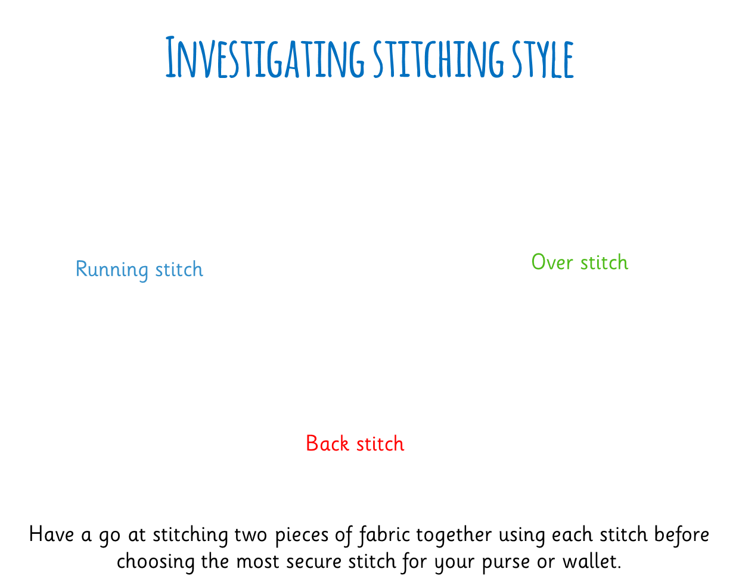

Key people / places

Resources
Collection of textile products selection of fastenings scissors glue
Items to use for finishing needles thread tape
Pins

Assessment questions / outcomes
How can we join different materials together?
Can you show me a running stitch?
Can you show me an over stitch?
How will your design meet the criteria?
Why have you chosen those colours/that design/those materials?
Can you show me how to cut safely and accurately?
How do you use a template?
Were you happy with your finished product? Did it meet the criteria?

