Topic: Mechanisms | Year group | Term
Design, make and evaluate a puppet to use as a story telling prop in the classrooms story corner. | Year 1 | Spring A  6 sessions
Background knowledge
People all around the world make puppets and have been doing so for thousands of years. Puppets are used for story telling, playing and even TV shows! They can be made out of a wide variety of materials eg. Wood, plastic, metal, paper or fabric. Additional enhancements could be added like beads or sequins, and a ribbon is needed for it to hang. They can be flat or 3D.
What should I already know?
- To be able to use simple tools (eg. Pencil and scissors) safely and with increasing control, to make changes to a material.
- Materials can come in all different shapes, sizes, colours and textures.

Key learning in design and technology
Designing
- Design a functional and appealing product for a chosen user and purpose based on a simple design criteria
- Generate, develop, model and communicate their ideas as appropriate through talking, drawing templates, mock- ups and information and communication technology

Making
- Select from and use a range of tools and equipment to preform practical tasks such as marking out, cutting, joining and finishing
- Select from and use textiles according to their characteristics

Evaluating
- Explore and evaluate a range of existing textile products relevant to the project being undertaken
- Evaluate their ideas throughout and their final products against the original criteria

Technical knowledge and understanding
- Understand how simple 3D textile products are made, using a template to create two identical shapes
- Understand how to join fabrics using different techniques eg. Running stitch, glue, over stitch, stapling
- Know and use technical vocabulary relevant to the projects

National Curriculum Objectives / Key Skills | The Journey
National Curriculum Objectives  - Design purposeful, functional, appealing products for themselves and other users based on design criteria  - Generate, develop, model and communicate their ideas through talking, drawing, templates, and mock-ups.  - Select from and use a range of tools and equipment to perform practical tasks.  - Select from and use a wide range of materials and components according to their characteristics.  - Explore and use mechanisms, (sliders, levers, wheels and axles) in their products.  - Explore and evaluate a range of existing products  - Evaluate their ideas and products against design criteria  As a year 1 designer KPI  - I can evaluate existing products to understand I can investigate how different materials join together.  - I can design something appealing and functional  - I can use my own ideas to make something out of textiles.  - I can join materials together (gluing)  - I can work safely to shape materials using a template and scissors.  - I can explain what went well with my work and think what I could do to make it better. | - WALT: Explore and compare existing products.  Explore and evaluate a range existing products eg. Joining techniques, finishing techniques and fastenings.  - WALT: Design a decoration  Focused Tasks- Demonstrate how to use a template. Mark our tape or pin the template to the fabric. Children draw a template discuss with partner how to make and verbally evaluate their design.  - WALT: Joining materials - Focused task- demonstrate the different ways of joining materials together staple, lacing, gluing. Children to have a go at these different methods and evaluate their effectiveness.  - WALT: Make puppet. Children now have knowledge of templates and joining materials they choose the most effective method and start their product.  - WALT: To embellish design using joining methods and finishes - Complete making the product, decorate and test? - take photos for later evaluation.  - WALT: Evaluate my product – Children to evaluate their finished product, communicating how it works and how it matched their design criteria, including any changes they have made.

Outcomes
An overview of what children will know / can do

Working towards: I can cut materials and join them together with support.
Expected: I can design a hanging decoration, working carefully and safely to cut and join the materials together.
Exceeding: I can design an appealing hanging decoration, working safely and carefully on my own.

Key Vocabulary | Timeline / Diagrams
Material- what the object is made of  Stitching- process of joining two materials together using a thin piece of thread and a needle, making joins between the two fabrics.  Gluing- Using an adhesive substance that dries clear to join materials.  Joining- When two things become linked or connected.  Design- to make or draw plans for the structure or form of.  Template- a paper model of the shapes you will need to cut out of a piece of a material, can be traced onto the material for an accurate shape. | 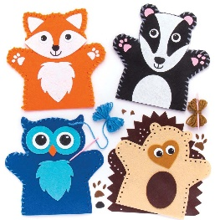  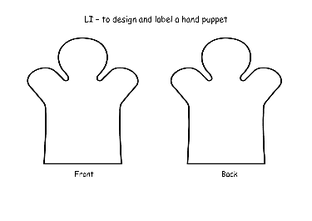

Key people / places
Assessment questions / outcomes
How can we join different materials together?
What do we need to think about when pinning, stapling, gluing?
How are you joining to pieces of fabric?
Why are you choosing this technique?
What will you need to decorate your puppet to make it look like your character?
How will you attach your decorations to your puppet?
What are the possible mistakes you need to think about and avoid?
Does your puppet look like your design?
Do you need to make any changes to your design?

Resources
Existing products Variety of textiles Dipryl
Felt Reclaimed fabric Thread
Pins Needles Magnets
Staples Fabric Glue Scissors
Buttons Wool Fabric paints
Sequins Drawing and colouring material

