Topic: Music | Year group
Friendship Song | Year 2
Morpeth First School Knowledge Organiser
Background knowledge
A soundscape, in this context, is like a story being told through sound. Events in the story are represented by different sounds and the soundscape will have a beginning, a middle and an end. ‘Chords’ are groups of notes played together. Some examples of chords include C major (C, E and G notes), D minor (D, F and A notes), F major (F, A and C notes), G major (G, B and D notes). The ‘home’ chord refers to the tonic chord, the first chord in any key; the one where most pieces of music start and end and represents a feeling of resolution to a piece of music. The conductor has to start and finish with the home chord (C major is the perfect chord to use). A minor scale is a series of notes with a sad, sombre character (exaggerated when heard back-to-back with a major scale). The major scale conveys a happy, cheerful mood.

What should I already know?
Year 1
I can make different sounds with my voice
I can make different sounds with instruments
I can identify changes in sounds
I can change the sound
I can repeat short patterns
I can make a sequence of sounds
I can show sounds using pictures
I can recognise repeated patterns
I can follow instructions about whether to play or sing

National Curriculum Objectives / Key Skills | The Journey
Experiment with, create, select and combine sounds using the inter-related dimensions of music.  I can order sounds to create a beginning, a middle and an end  I can create music in response to different starting points  I can choose sounds which create an effect  I can use symbols to represent sounds  I can make connections between notations and musical sounds  I can improve my own work | - Recap names of some musical instruments. Read the story of Jack and the Beanstalk, explaining that we are going to explore the sounds we might hear if we were in the story (see below for examples of sounds). Which instrument could we use for each sound? Recap on volume and tempo from Year 1 to explore sounds further. Children work in small groups to find the best sound for each event in the story.  - Recap last week and go through the instruments we could use for each incident in the story. Children to work in small groups and decide on three events from the story that they will use in their soundscape. Children draw three pictures to show the three events and then decide which instruments or vocal sounds they will use to represent each picture. Children perform their soundscapes.  - How could we improve our performances from last week? Introduce the idea of a conductor in each group and come up with actions meaning ‘start’ and ‘stop’. One child in each group to take on the role of the conductor and continue to rehearse soundscapes from last week but with every member of the group starting and stopping at the same time.  - Explain and work with the children on recognising the difference between single individual pitches or ‘notes’ and groups of notes played together or ‘chords’. Children explore the different sounds and are given the chance to play individual notes on their own and chords as part of a group.  - Split the children into 4 groups and give each child a tuned percussion instrument (chime bars or bells). Select major and minor chords for the groups to play and mark one of the groups ‘home’ (See ‘background knowledge’ for options of chords to use). Recap on previous lesson and model how to record each chord as a picture (children can support in deciding what picture should represent each chord). Remind the children that we must start and finish on the ‘home’ chord. Model taking on the role of the conductor and following the pictures to conduct a group. Children to be split into groups with a designated conductor and repeat last week’s activity by drawing which chords they will play and in which order before rehearsing and performing to the class. Groups give each other feedback before being given more rehearsal time in an effort to improve their work.

Outcomes
An overview of what children will know / can do

Working towards: I know the names of some musical instruments and am starting to play some of these correctly. I know what different gestures made by a conductor mean. I can offer ideas for how to represent sounds or events from stories pictorially.

Expected: I can name some musical instruments and play them correctly. I can follow the gestures of conductor and play an instrument when instructed. I can record sounds on paper using pictures. I know the difference between individual notes and chords (groups of notes). I can think of the best way to represent an event from a story with a sound or a picture.

Exceeding: I can conduct a group using the correct gestures and can also follow the gestures of conductor and play an instrument or stop when instructed. I can record sounds on paper using pictures and follow these pictures to conduct a group. I know the difference between individual notes and chords (groups of notes) and can name some chords. I can give constructive feedback on how a group could improve their work.

Key Vocabulary | Timeline / Diagrams
Instrument – a device created or adapted to make musical sounds.  Conductor – a director of a musical performance.  Performance – the act of presenting music.  Soft – quiet.  Loud – much noise.  Volume – loud or quiet/soft.  Fast – high speed.  Slow – low speed.  Tempo – fast or slow.  Note – a single musical sound.  Chord – a group of (typically three or more) notes sounded together.  Soundscape – a story being told through sound.  High – a high frequency sound which can be described as shrill or piercing.  Low – a low frequency sound which can be described as deep or soft.  Pitch – high or low.  Major (in child’s terms) – notes with a happy, cheerful character.  Minor (in child’s terms) - notes with a sad, sombre character. | 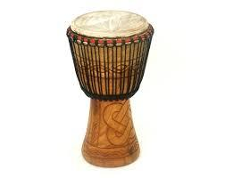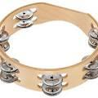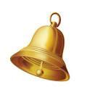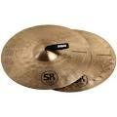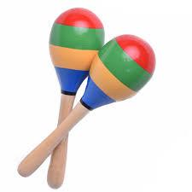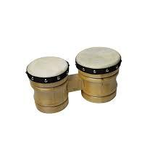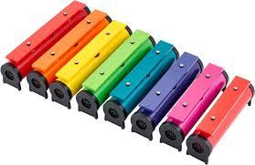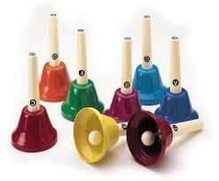

Key people / places
“Music expresses that which cannot be said” – Victor Hugo.

Assessment questions / outcomes
What are the names of these instruments?
How do you play this instrument?
What does volume mean?
What does tempo mean?
What does a conductor do?
What is the sign for start/stop?
What is a chord?
Can you name any chords?
What do minor/major chords sound like?

Jack and the Beanstalk sounds to explore:
• Mum doing all the work (chopping wood, digging the garden) while Jack idles his time away.
• Jack and Daisy walking to market
• Mum’s anger when she sees the beans
• The sound of the beans hitting the ground
• The stealthy growth of the beanstalk overnight
• Jack climbing the beanstalk
• The giant’s famous chant ‘Fee, fi, fo fum…’
• The magic hen calling to her master
• The axe chopping down the beanstalk
• The clink of money now that Jack and his mother are rich!

