Topic: Textiles | Year group | Term
Design make and evaluate an activity mat for a baby. | Year 4 | Autumn 1  4 sessions

Background knowledge
- Activity or sensory mats were developed to engage babies and toddlers, providing them with different textures, colours, sounds and activities to build motor skills.
- They should include different fabrics, different embellishments, buttons, fastenings and attachments.
- It is also the first time children will really be thinking about an audience other than themselves in their textile projects.

What should I already know?
- Fabrics come in a wide range of colours, textures and thicknesses.
- Materials can be joined together in different ways; gluing, weaving, basic sewing have been covered so far), running stitch and over stitch.
- They should know how to work safely with scissors, use templates or simple pattern pieces
- They would have evaluated a range of textile products

National Curriculum objectives
Designing
- Generate realistic ideas and design criteria collaboratively through discussion, focusing on the needs of the user and purpose of the product.
- Develop ideas through the analysis of existing products and use annotated sketches and prototypes to model and communicate ideas.

Making
- Order the main stages of making.
- Select and use appropriate tools to measure, mark out, cut, score, shape and assemble with some accuracy.
- Explain their choice of materials according to functional properties and aesthetic qualities.
- Use finishing techniques suitable for the product they are creating.

Evaluating
- Investigate and evaluate a range of existing shell structures including the materials, components and techniques that have been used.
- Test and evaluate their own products against design criteria and the intended user and purpose.

Technical knowledge and understanding
- Develop and use knowledge of how to construct strong, stiff shell structures.
- Develop and use knowledge of nets of cubes and cuboids and, where appropriate, more complex 3D shapes.
Know and use technical vocabulary relevant to the project.

Key Skills | The Journey
As a Year 4 Designer KPI  - I can explore and use existing products to investigate what my product needs.  - I can suggest some design criteria to suit the purpose and audience of the product.  - I can produce a plan and explain it, including annotated sketches.  - I can use templates to help create my own simple pattern pieces for my design.  - I can make a product from textiles explaining how I will join them and why. (stitches/gluing)  - I can independently select from a wider range of tools and materials explain my reasons for these.  - I can persevere and adapt the process to overcome problems  - I can evaluate my design against the criteria and suggest improvements for my design. | 1.Walt: Investigate existing products  Look at the product, discuss its purpose and who the product is aimed at. Suggest design criteria as a class and decide together. Investigate a range of fabrics, materials, embellishments etc.  2. Walt: Design my activity mat  Draw an annotated sketch of their finished design, make any pattern pieces they will need to make their product next week. Discuss their reasons for choosing certain colours/textures.  3. Walt: Make an activity mat  Model basic sewing techniques to refresh their memories. Children make their activity mats.  4. Walt: Evaluate the finished product  Complete making the product if necessary and finish neatly. Evaluate and prove how the product meets the design criteria. Gain peer feedback to suggest how they could improve their product.

Outcomes
An overview of what children will know / can do

Working towards: I can cut materials carefully and join materials in different ways

Expected: I can design an appealing and functional product for the target audience, Using a range of materials, embellishments and skills to join them together.

Exceeding: I can create a design that is well made and engaging for the user.

Key Vocabulary | Timeline / Diagrams
Audience- the group of people the product is intended for.  Market Research- Gathering information about a product and its intended audience.  Pattern Pieces- templates made from paper that are traced onto fabric before being cut out.  Design Criteria- Key points the product must include in order to be successful.  Embellishments- Decorative or functional items attached to a product to add value to the design. | 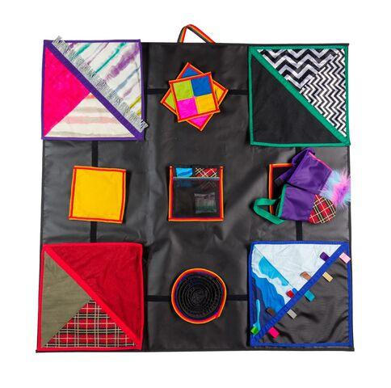

Key people / places

Resources
Collection of textile products selection of fastenings scissors glue
Items to use for finishing needles thread tape
Pins
Assessment questions / outcomes
How can we join different materials together?
Can you name some different fabrics we could use?
How will your design meet the criteria?
Why have you chosen those colours/that design/those materials?
Can you show me how to cut safely and accurately?
How do you use a template?
Were you happy with your finished product? Did it meet the criteria?

