Topic: Structures | Year group | Term
Design, make and evaluate a pier to help the people who live on Isle of Struay to deliver parcels on and off the island | Year 2 | 6 sessions
Background knowledge
A pier is a raised walkway across water. It can be a simple light wooden structure which has no effect on the current and tides, or a major structure with buildings and as long as a mile out to sea.
What should I already know?
- Materials can be joined using glue or tape and shaped using scissors
- We can use a range of materials to make models or structures
- Children will have experience of different joins after their Year 1 houses project
National Curriculum Objectives
Designing
- Generate ideas based on simple design criteria and their own experiences, explaining what they could make.
- Develop, model and communicate their ideas through talking, mock-ups and drawings.

Making
- Plan by suggesting what to do next.
- Select and use tools, skills and techniques, explaining their choices.
- Select new and reclaimed materials and construction kits to build their structures.
- Use simple finishing techniques suitable for the structure they are creating.

Evaluating
- Explore a range of existing freestanding structures in the school and local environment e.g. everyday products and buildings.
- Evaluate their product by discussing how well it works in relation to the purpose, the user and whether it meets the original design criteria.

Technical knowledge and understanding
- Know how to make freestanding structures stronger, stiffer and more stable.
- Know and use technical vocabulary relevant to the project.

Key Skills | The Journey
As a year 2 designer KPI  - I can use existing products to get ideas for my design, thinking about what it is for.  - I can draw a plan for my design  - I can think of an idea and plan what to do next  - I can build a structure out of card, lollypop sticks paper or plastic  - I can make informed choices about tools and materials  - I can join materials in different ways (glue, tape) and think about how to finish it in a neat way.  - I can explain what went well with my work and how I could make it better.  - I can prove that my design meets the criteria can explain | - WALT: Investigate existing piers, locally and globally. What is their purpose? What shapes are they? What are they built from?. Ask children to make some sketches and label common features  - WALT: Investigate joining materials together. Demonstrate measuring, marking out, cutting, shaping and joining materials. Explore attaching different shapes and pieces together-look at images; can they guess how it has been joined together? Can they recreate as a team?  - WALT: Design pier. As a class generate some simple design criteria. Encourage children to develop ideas by talking, drawing and making mock ups.  - WALT: Make a pier in pairs. Discuss key features their piers will need to have and explain their reasoning for choosing the materials that they have chosen.  - WALT: Improve my model- looking at how to make it stronger and sturdier. Set a design challenge – Can your pier hold a parcel?  - WALT: To evaluate the final product Discuss how successful piers were against the criteria set by the class. Evaluate the d4esihgn and suggest ways of improving it next time.

Outcomes
An overview of what children will know / can do

Working towards: I can build a pier
Expected: I can use my research to design and make a sturdy pier
Exceeding: I can use my research to make a strong, sturdy pier that meets the design brief
Key Vocabulary | Timeline / Diagrams
Purpose- what something is for/meant to do  Strength- the ability of something withstand a lot of pressure/force  Sturdy- holds still and strong, well built  Freestanding- Stands on its own without guy ropes  Foundations- load bearing part of a building or structure. Usually the base level.  Product- something made by means of either human work or that of a machine.  Function- the purpose or role that an object fulfils or is suited for  Stable – Does not topple over easily  Unstable – Topples over easily  - Design Criteria – the goals that a project must achieve in order for it to be successful | 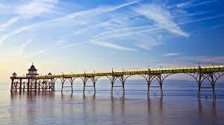  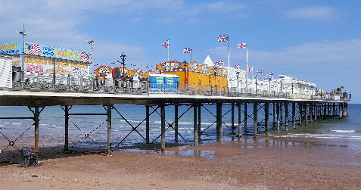

Key people / places

Assessment questions / outcomes
Name some famous piers
Did you spot any common features of strong piers?
Which shapes are the strongest?
Which material will you build your pier out of? Why?
How will your design match the brief?
How will you join your materials together?
Was your design successful? Why/why not?
How would you improve it next time?

Resources
Photographs of various piers, construction kits that can be used to construct freestanding structures
paper, card, plastic sheet, paper and plastic straws, pipe cleaners, reclaimed materials including small containers, card boxes, cotton reels, string, masking tape , PVA glue, plasticine, left/right handed scissors, hole punch, stapler, finishing media and materials

