Topic: Mechanisms | Year group | Term
Design, make and evaluate a moving Christmas card for a parent to buy at the Christmas fair | Year 1 | 6 sessions
Background knowledge
Moving pictures includes the different ways that you can make a picture move in a book, pop up is the most simple example of this, however in this unit children will focus mainly on using sliders and simple levers. They will need to build an understanding of how one part can affect another to design their Christmas cards.
What should I already know?
- Early experiences of working with paper and card to make simple flaps and hinges
- Experience of simple cutting, shaping, and joining skills using scissors, glue and paper fasteners and masking tape

National Curriculum Objectives
Designing
- Generate initial ideas based on simple design criteria and their own experiences, explaining what they could make
- Develop, model and communicate their ideas through drawings and mock-ups with card and paper

Making
- Plan by suggesting what to do next
- Select and use tools, explaining their choices, to cut, shape and join paper and card
- Use simple finishing techniques suitable for the product they are creating

Evaluating
- Explore and evaluate a range of existing products that use simple leavers– eg books, cards puppets
- Evaluate their product by discussing how well it works in relation to the purpose and the user and whether it meets design criteria

Technical knowledge and understanding
- Explore and use sliders and leavers
- Understand that different mechanisms produce different types of movement
- Know and use technical vocabulary relevant to the projects

Key Skills | The Journey
As a year 1 designer KPI  - I can investigate and describe how something works. (levers and sliders)  - I can design something for someone else.  - I can use my own ideas to make something that moves using a lever or slider  - I can cut carefully and safely  - I can make my design stronger by choosing appropriate materials.  - I can choose appropriate resources and tools.  - I can explain what went well with my work | - WALT: Understand how sliders and leavers work  Explore and evaluate a range of everyday objects that have moving parts Draw an example of a wheeled product, stating the user and purpose and label the main parts.  - WALT: Make a moving picture with a sliders and leavers  Teacher models this process and children make a replica of the one the teacher has made. Focused task -to learn the skills to make this mechanism.  - WALT: Design a picture with a moving slider or leaver with the children identify the user and the purpose of the product. Share ideas verbally and through drawings make time to evaluate  - WALT: Make a moving picture product – Talk about the finishing techniques they might use eg. Paint felt or pens  - WALT: Evaluate my product – Ask the children to evaluate their design against the original criteria decided by the class. . A picture could be taken and they do this verbally or written

Outcomes
An overview of what children will know / can do

Working towards: I can cut pieces out independently, and with support make a slider or lever.
Expected: I can make a slider or lever to make a moving picture.
Exceeding: I can use multiple mechanisms in my design, working accurately and safely.

Key Vocabulary | Timeline / Diagrams
Moving Picture- An image that has moving parts, using levers, sliders or wheels.  Slider- A bar or handle that you pull along or slide along to make another part move along, or up and down. It remains in contact with the base and is usually kept in place by a pocket cut out of the base.  Lever- A lever is a bar or handle that you push or pull to make another part move.  Pivot – a rod or pin upon which another part rotates, swings, or moves back and forth.  Join - to put, bring, or fasten together.  Make - to bring into being by building from separate parts.  Evaluate- to study carefully and judge.  Split pin- a small metal pin that can hold two pieces together but still allow movement. It is secured by splitting the butterfly back.  Material- What you choose to make your levers and sliders out of. | 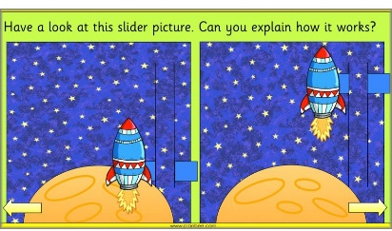  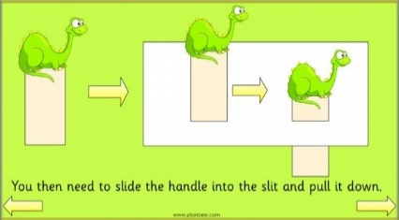
Resources
Books and everyday products with leavers and slider mechanisms
Slider and leaver teaching aids

Card strips card rectangles paper
Masking tape paper fasteners paper binders
Stick glue PVA glue finishing materials
Scissors cutting mats card drill

Assessment questions / outcomes
Can you tell me when you might use a lever, what would it do?
Can you tell me when you might use a slider, what would it do?
How does this slider/lever work?
Can you tell me how to make a slider?
Can you tell me how to make a lever?
What is wrong with this slider/lever? Why won’t it work?
Why did you decide to use a lever/ slider? Why is that the best choice for your picture?
Were you happy with your moving picture?
What would you change?
Did it match your design?

Key people / places

